Asparagus - Eat

Steamed, Roasted, Stir-Fried, Grilled
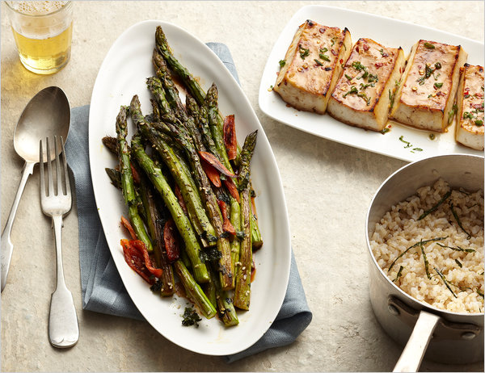
Photograph: Yunhee Kim for The New York Times. Food Stylist: Maggie Ruggiero. Prop Stylist: Deborah Williams.

By MARK BITTMAN

Published: April 27, 2011

It takes effort to maintain a sense of seasonality with asparagus, given that it has become a year-round product. But right now even the stuff in supermarkets may come from a local source — so that the stalks snap rather than bend when you apply pressure and the aroma and flavor are fresh rather than simply strong.

Multimedia
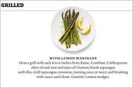Graphic

Asparagus Flow Chart
Still, even the best asparagus needs something, even if it’s as little as olive oil and lemon. Hence the following below, with the best cooking methods — steaming (or poaching; in the case of asparagus, they’re roughly equivalent); roasting; grilling (or broiling, which is always an alternative, because the broiler is nothing but an upside-down grill); and stir-frying — and flavors well suited to each.
There are several varieties of asparagus, including white, which is, in my experience, overrated. (You Northern Europeans may yell at me all you like; I’ve tried it everywhere.) The most relevant difference for most of us is thick versus thin, and you can use either in any recipe here. In the 1990s, I considered skinny asparagus far superior to fat, because it requires no peeling and cooks in a flash. A few years ago, I began to better appreciate the delicious snap of thick spears as well as their relative sturdiness. Certainly if you’re steaming or grilling, thick is the preferable type. It really should be peeled; it will look, taste and bite more nicely if you take the time. And with thick or thin, you can snap the bottoms off or go the easier route and just chop off the last inch or two with a chef’s knife.
You might prefer asparagus crisp-tender or softer than that; either way, it’s done when you can pierce the thickest part of a spear with a sharp knife without much resistance. This might take less than five minutes for very slender asparagus, twice that long for thick. (Roasting is the slowest of the cooking methods here.) For all of these recipes, use 1 1/2 to 2 pounds to serve four people, and as always, add salt and black pepper to taste.
1. STEAMED
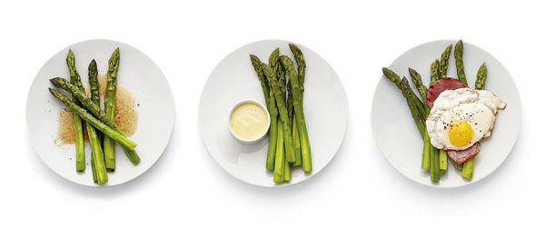
With Brown Butter
Put asparagus in a covered pot with an inch of water (they may stand, lean or lie flat) and turn heat to high. Put 2 to 4 tablespoons butter in a small saucepan over medium heat; stir occasionally until foam subsides and butter turns nut brown. When asparagus is done, drain, drizzle with butter and serve.
With Aïoli
Skip brown butter. Put an egg yolk in a food processor with 2 teaspoons Dijon mustard, 1 to 4 peeled garlic cloves, 1 tablespoon lemon juice and 1 teaspoon lemon zest. Turn it on and drizzle in 1 cup olive oil; an emulsion will form. Serve asparagus dipped in aïoli.
With Fried Eggs and Ham
Skip brown butter. Melt 2 tablespoons butter in a large skillet over medium heat. Add 4 slices good ham and cook gently on both sides; remove. Add 2 more tablespoons butter in skillet and fry four eggs until whites are firm. Serve asparagus topped with ham, eggs and any pan juices.
2. ROASTED
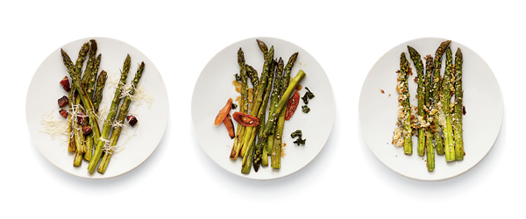
With or Without Bacon
Heat oven to 450. Toss asparagus with 2 tablespoons olive oil (more if you don’t use bacon) and 4 ounces cubed bacon (optional) in a roasting pan. Roast, turning once or twice, until done. Garnish: Grated Parmesan.
With Carrots, Sesame and Soy
Skip bacon. Substitute sesame oil for the olive oil and add 2 thinly sliced carrots to roasting pan. After 5 minutes of roasting, sprinkle with 1 tablespoon sesame seeds. When done, drizzle with soy sauce and toss. Garnish: Crumbled toasted nori.
With Blue Cheese and Bread Crumbs
After 5 minutes of roasting, turn asparagus and top with 1/2 cup fresh bread crumbs and 1/4 cup crumbled blue cheese. Continue to roast without turning until asparagus is done. Turn on broiler and broil until top browns, about 1 minute.
3. STIR-FRIED
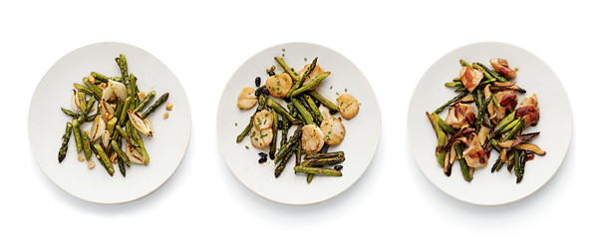
With Shallots and Fish Sauce
Put a large skillet over high heat for 3 minutes. Add 2 tablespoons peanut oil, then asparagus — cut into 2-inch lengths — and 10 halved shallots. Cook, stirring, until asparagus and shallots are dry and beginning to brown. Add 2 tablespoons water and 1 tablespoon fish sauce; cook until done. Garnish: Chopped peanuts.
With Scallops and Black Beans
Soak 1 tablespoon fermented black beans in sake or white wine to cover while pan heats. Substitute 1 tablespoon minced garlic for the shallots and soy sauce for the fish sauce. Add black beans and 1/2 pound sliced or cubed scallops to pan along with soy sauce and water. Garnish: Chopped chives.
With Chicken and Shiitakes
Skip shallots. When pan is hot, add oil, then 1/2 pound cubed chicken thighs. Cook, stirring occasionally, until browned; remove. Add asparagus and 1/2 pound trimmed and sliced shiitake mushrooms; proceed, substituting oyster sauce for the fish sauce. Add chicken back to pan along with oyster sauce and water. Garnish: More oyster sauce.
4. GRILLED
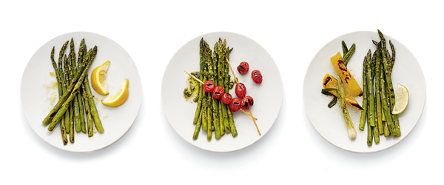
With Lemon Marinade
Heat a grill with rack 4 to 6 inches from flame. Combine 2 tablespoons olive oil and zest and juice of 1 lemon; brush asparagus with this. Grill asparagus crosswise, turning once or twice and brushing with sauce until done. Garnish: Lemon wedges.
With Grape Tomatoes and Pesto
Skip lemon; grill 1 pint grape tomatoes, skewered, with the asparagus, brushing all with olive oil. Purée 1 cup basil leaves, 1 small garlic clove, 1 tablespoon pine nuts, 1/4 cup (or more) olive oil and 1/4 cup grated Parmesan in a mini food processor. Serve asparagus and tomatoes with pesto.
With Red-Pepper Glaze
Substitute lime zest and juice for the lemon; add 1 tablespoon honey and 1/2 teaspoon (or more) red-pepper flakes. Grill 1 yellow bell pepper — cut into thick strips — and 4 trimmed scallions along with the asparagus, brushing all with the glaze. Garnish: Lime wedges.

